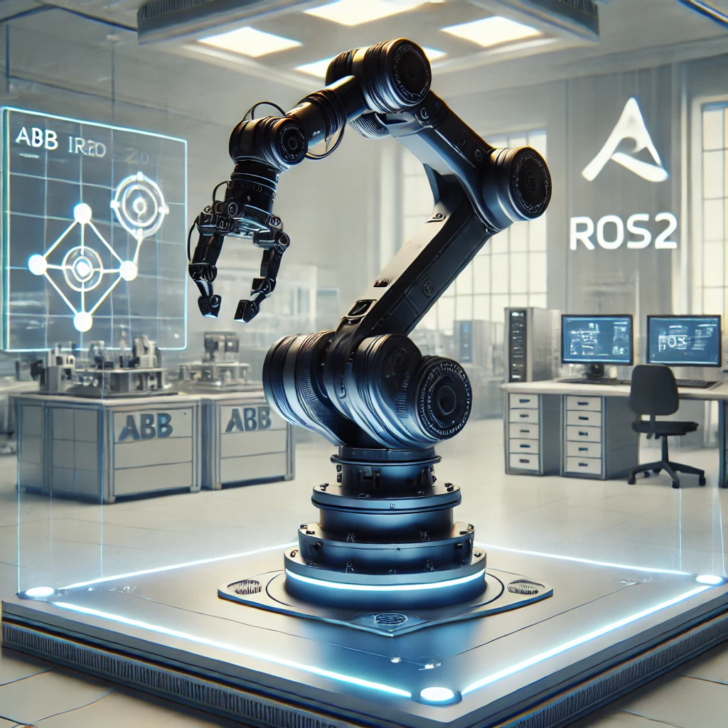

MCT344
Industrial Robotics




AIN SHAMS UNIVERSITY
FACULTY OF ENGINEERING
International Credit Hours Engineering Programs (I.CHEP)

MCT344
Industrial Robotics

First Milestone
Supervised By:
Dr.Shady Ahmed,
Eng.Mina Yousry,
Eng. Dina Zakaria.

Team Members
Name | ID
Philopateer Elkes | 21P0240
Yahia Mohamed | 21P0041

Table of Contents
Abstract: 4
1.0 Introduction 5
2.0CAD Model Import & URDF Conversion 6
4.0 Configuring ROS2 Controllers 8
5.0 Creating the Launch File 10
6.0 Drive Link 13

List of figures:
Figure 1:CAD Model 6
Figure 2:Joint Names 7
Figure 3:Joint controller.yaml 8
Figure 4:Joint controller.yaml 2 9
Figure 5:Launch file 1 10
Figure 6:Launch file 2 11
Figure 7:Launch file 3 12
Figure 8:Robot in Gazebo 13

Abstract:
This report presents the modeling and simulation of an ABB IRB 1200 robotic arm with a custom-designed two-joint gripper end-effector in the ROS2 and Gazebo environments. The objective of this milestone was to develop a 6-DOF manipulator using the Unified Robot Description Format (URDF), ensuring compatibility with Gazebo for realistic physics-based simulation. The project involved defining the robot’s kinematics, visual properties, and dynamics, configuring ROS controllers for joint actuation, and integrating the model into a launch system for seamless execution in Gazebo. The final implementation allows for controlled movements of the robotic arm and gripper using ROS2 commands, demonstrating successful simulation and validation.

1.0 Introduction
Industrial robotic arms are widely used in automation, manufacturing, and precision assembly, requiring accurate simulation for design validation and control testing. In this milestone, we focused on modeling and simulating the ABB IRB 1200 robotic arm, a widely used 6-DOF manipulator, and designing a two-joint gripper end-effector to extend its capabilities.
Using ROS2 and Gazebo, we developed a URDF-based robot model, defining its links, joints, and physical properties. The simulation was enhanced by incorporating joint constraints, dynamic parameters, and ROS controllers, ensuring smooth and realistic operation. A .yaml configuration file was created to define the necessary joint controllers, and a .launch.py script was implemented to deploy the robot in Gazebo efficiently.
This report outlines the design process, simulation setup, controller configuration, and validation steps. Key challenges, such as URDF errors, Gazebo physics tuning, and controller integration, are discussed along with solutions implemented to ensure a functional and responsive robotic system. The final result is a realistic simulation of the ABB IRB 1200 with a working two-joint gripper, capable of controlled movements within a virtual environment.

2.0CAD Model Import & URDF Conversion
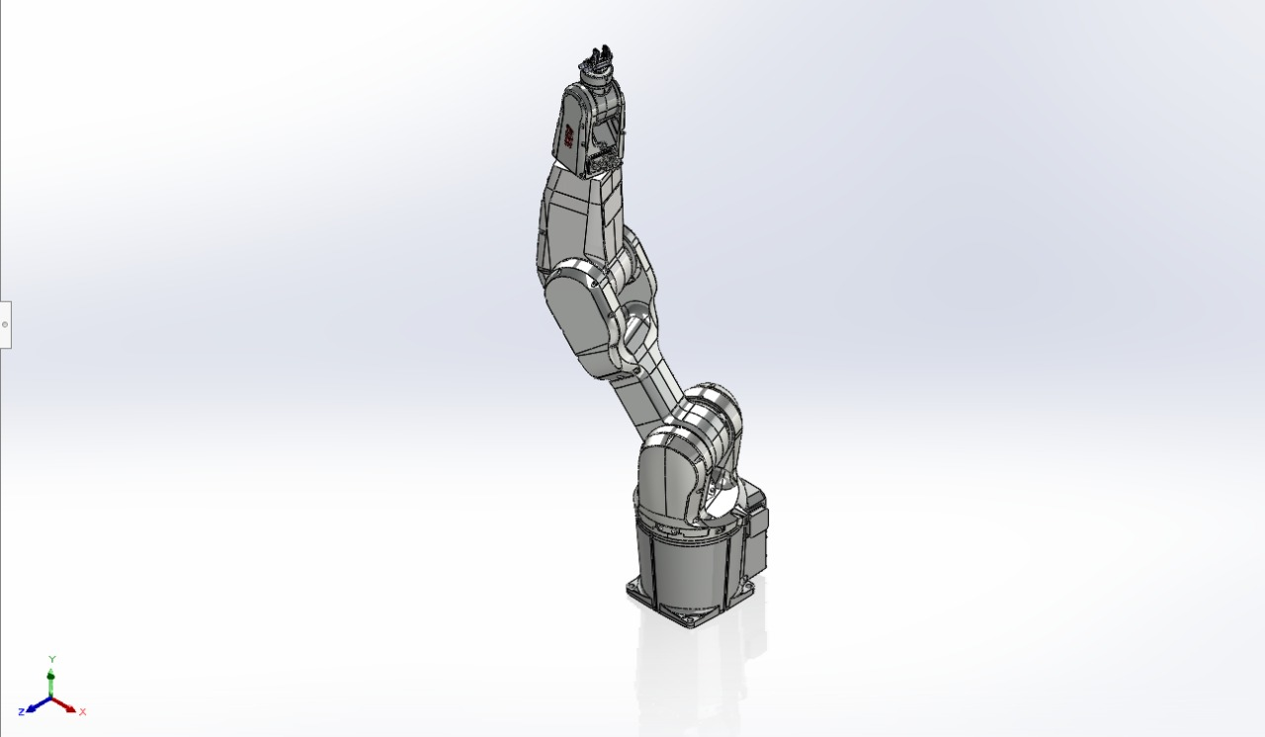
Figure 1:CAD Model

To integrate the robotic arm with ROS2, we exported the SolidWorks assembly as a URDF file using the SolidWorks URDF Exporter Plugin. During the export process, each link and joint was carefully named and assigned realistic mass and inertia values.
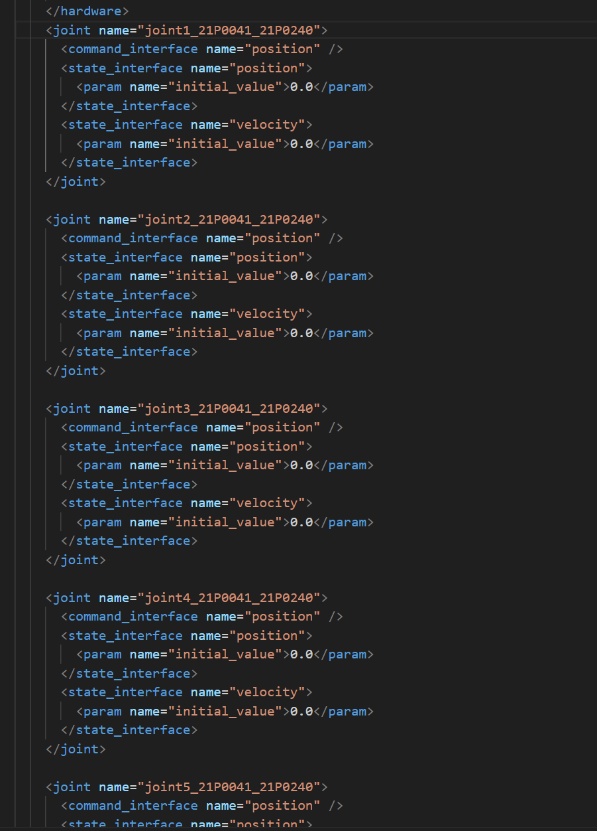
Figure 2:Joint Names

4.0 Configuring ROS2 Controllers
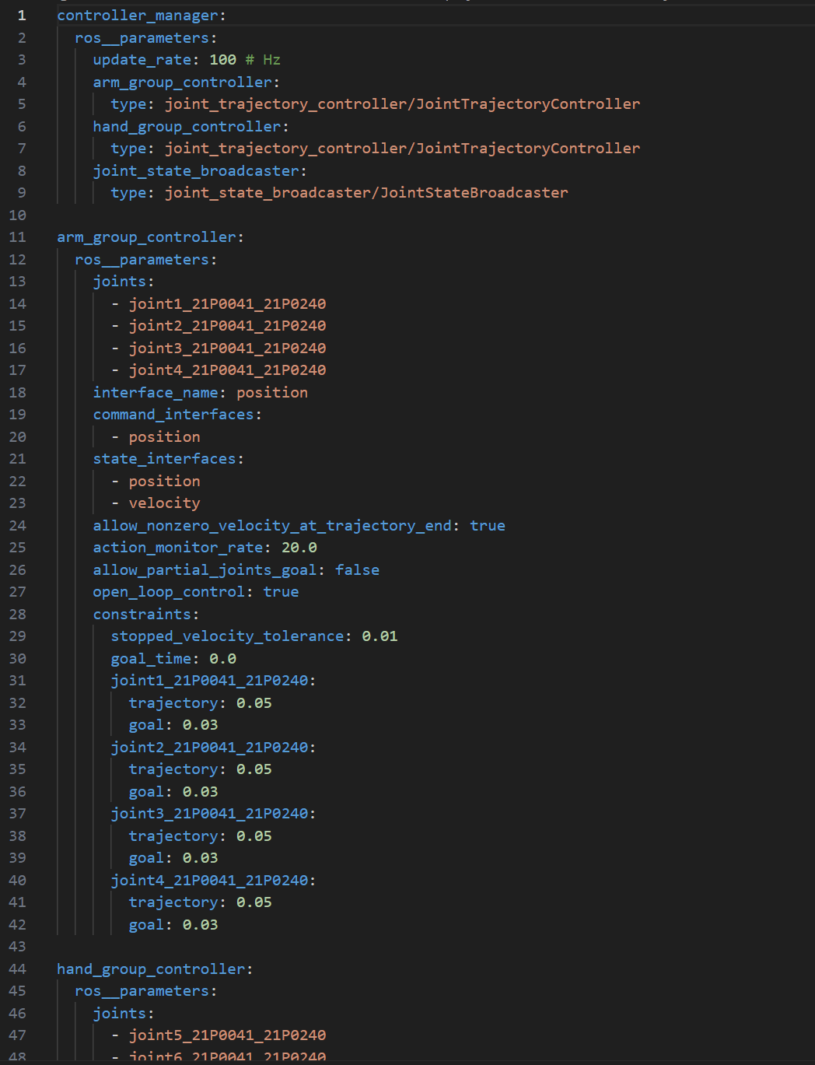
Figure 3:Joint controller.yaml
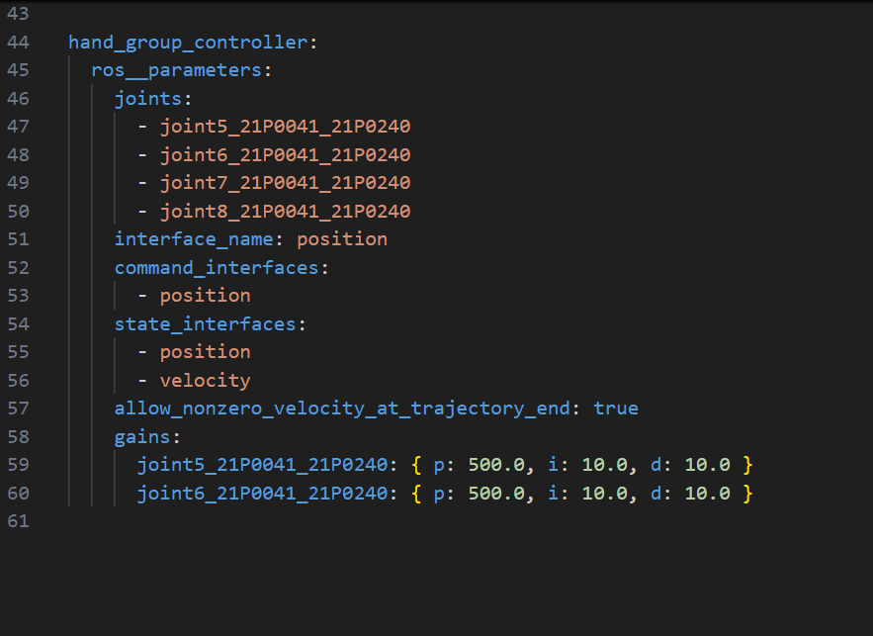
Figure 4:Joint controller.yaml 2

5.0 Creating the Launch File
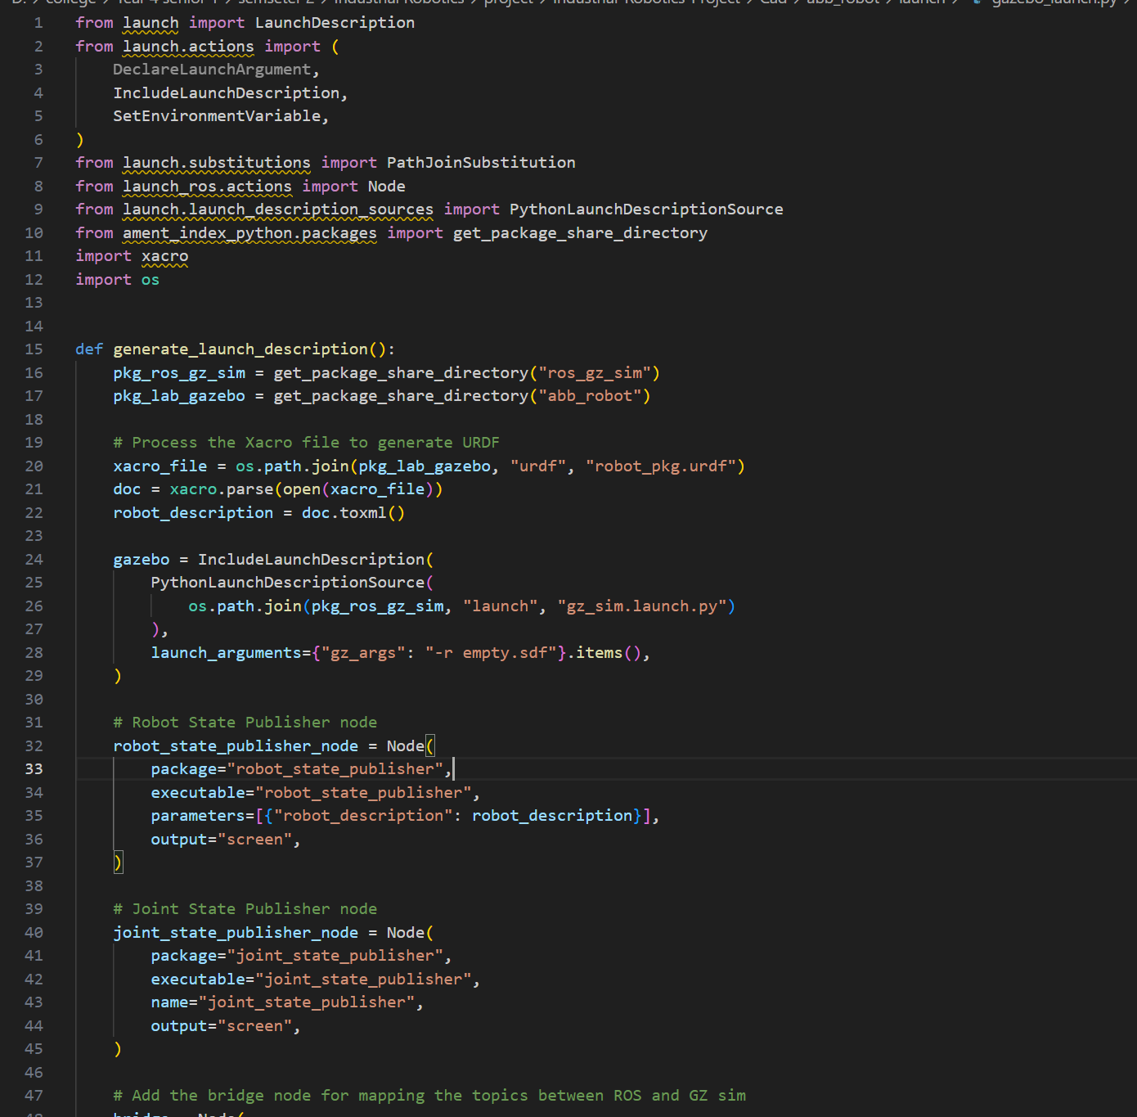
Figure 5:Launch file 1
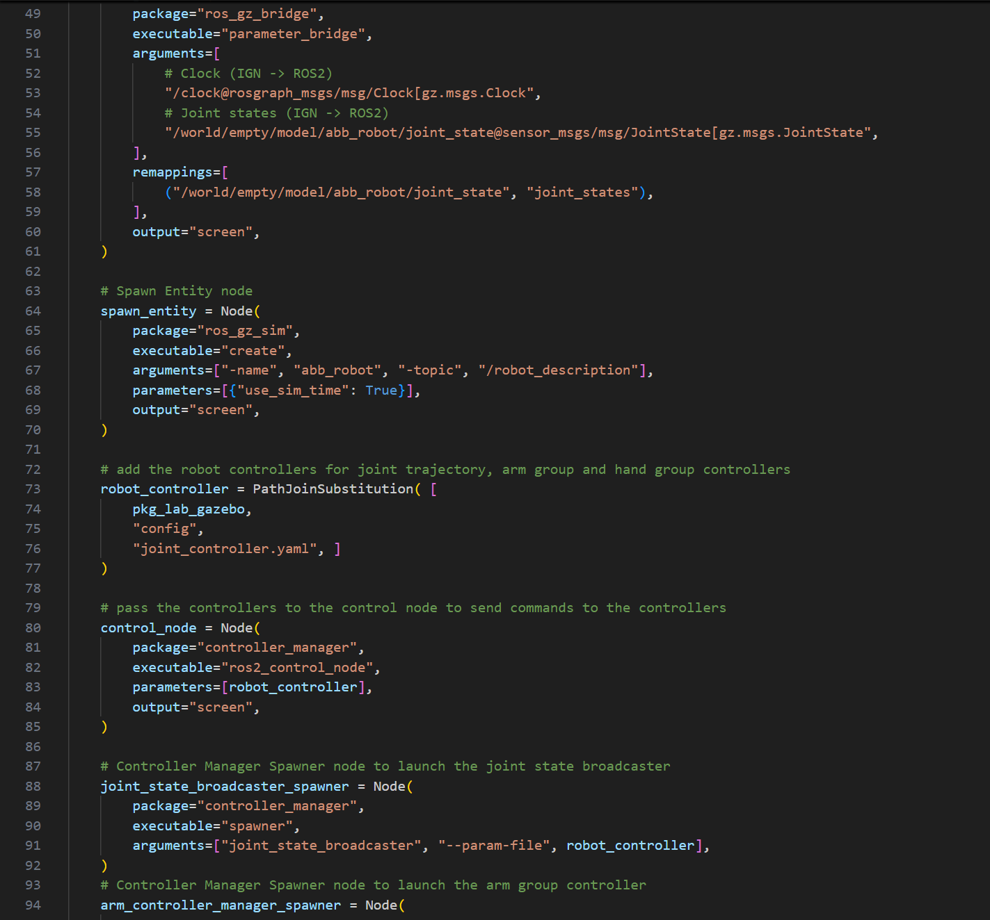
Figure 6:Launch file 2
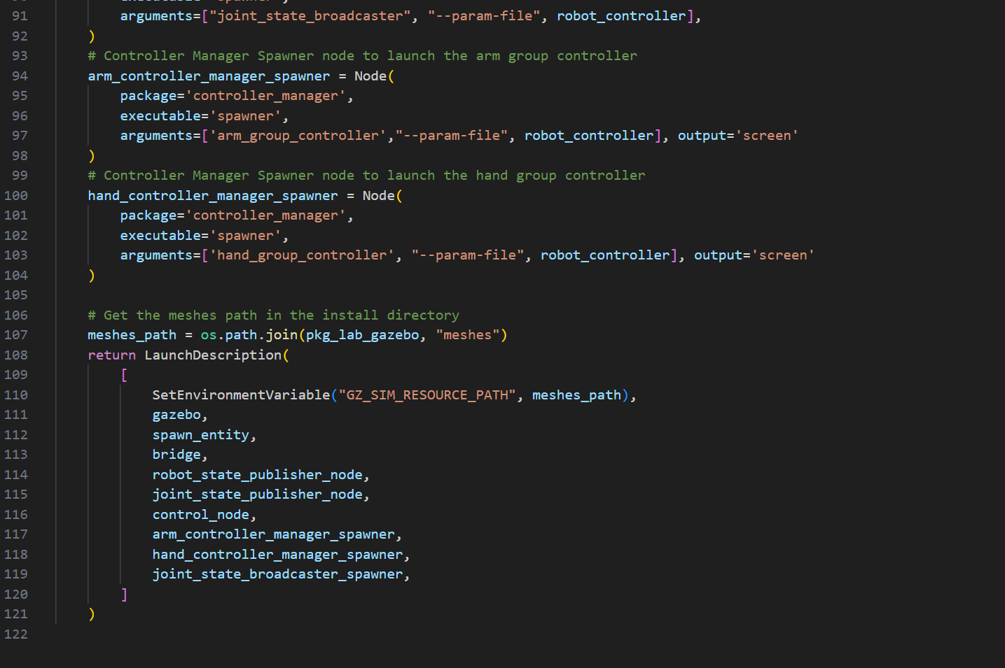
Figure 7:Launch file 3

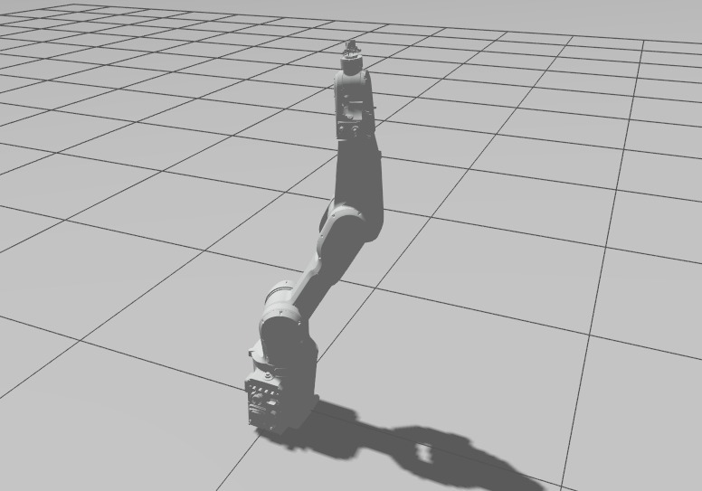
Figure 8:Robot in Gazebo

6.0 Drive Link
https://drive.google.com/drive/folders/1Bjn4gtHMUtRtRiE3VrS5pSFjiBGGSxiS?usp=sharing

